W-19
YEAR 10 SCIENCE (GENERAL)
PHYSICAL SCIENCE
TEST 1
Name: Mark: $\frac{}{\text{18}}$

Part 1: Multiple Choice
MULTIPLE CHOICE ANSWERS
1
2
3
4
5
6

Write your choice for each question in the table below.

1. How long would a car travelling at a speed of 20 m/s take to cover a
distance of 360 m?

(a) 13 s
(b) 26 s
(c) 18 s
(d) 34 s

2. Speed is a measure of the rate:

(a) at which distance is covered.
(b) at which speed increases.
(c) of change in force.
(d) of change in acceleration.

3. Belinda walks a total distance of 1200 metres to school each morning. If this trip takes her 800 seconds, her average speed would be:

(a) 1.5 m/s.
(b) 0.67 m/s.
(c) 0 m/s.
(d) 960,000 m/s.

4. A car is driven along a highway at an average speed of 90 km/h for 2 hours without a rest stop. What distance has it covered?

(a) 45 km
(b) 180 km
(c) 360 km
(d) Not enough information is given to calculate.

5. A car travels 400 km on a highway at a speed of 80 km/h. What time does the trip take?

(a) 0.5 hours
(b) 5 hours
(c) 20 hours
(d) 50 hours

6. The sample of ticker tape below shows:

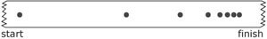

(a) a uniformly accelerating vehicle.
(b) a vehicle travelling at a constant velocity.
(c) a stationary vehicle.
(d) a uniformly decelerating vehicle.

Part 2: Short Answer

1. Describe or define the following terms. (2 marks)

(a) distance:

(b) displacement:

2. Decide whether each of the following statements is true (T) or false (F). (3 marks)

• Average speed is calculated by distance covered multiplied by the
time taken.

• 40.0 km/h = 144 m/s

• The relationship between time, distance and speed is $t =\frac{sp}{d}$ .

3. The map below shows Broome and Alice Springs. Use the map and its scale to work out the following.

(a) The distance between Broome Airport and Alice Springs airport. (1 mark)

(b) The displacement between the two airports. (HINT: Don't forget to include a bearing and start from Broome.)
(3 marks)

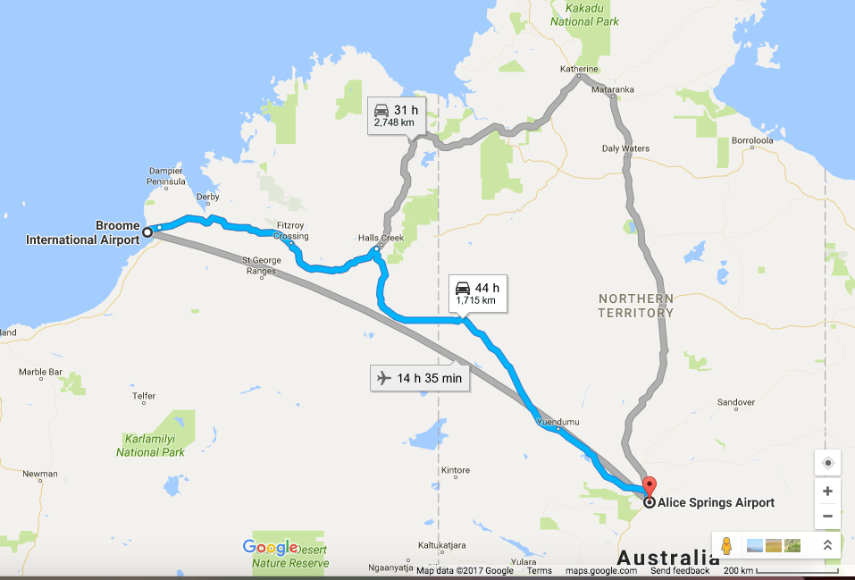

4. Complete the following table on speed calculations. Make sure you include the appropriate units for each quantity.
(3 marks)

Distance travelled | Time taken | Average speed
490 m | 35 s
 | 12 s | 23 m/s
121 m |  | 11 m/s

YEAR 10 SCIENCE
PHYSICAL SCIENCES
PHYSICS DATA SHEET

sp
d
t
Speed

v
s
t

Velocity

Acceleration v = u + at

m
F
a
Force F = ma

Weight F_{w} = mg
m
F_{w}ww
g

Acceleration due to gravity g = 9.80 ms⁻²

Converting km/h to m/s Divide the speed in km/h by 3.6 to get the speed in m/s.

